 W150M (W150M+)-How to configure the Wireless Router Mode?
Product line: Wireless Question category: Function configurations

Q: When we need to configure the W150M as Wireless Router Mode?
A: In the Wireless Router Mode, the W150M can be worked as the router with wireless NAT function and DHCP sever. The laptops connect to the W150M can get IP addresses automatically and connect to the Internet normally.
Common network connection topology is as follows.
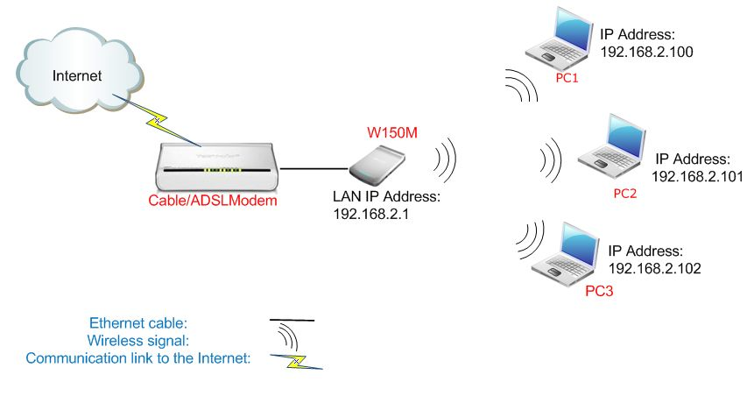
The Steps are as follows:
- Connect the computer to the W150M by an Ethernet cable.
- Login to the management page of the W150M.(the login IP is default to be 192.168.2.1, the username and password are both admin).
- In the management page , choose the default mode Wireless Router->Setup Wizard. In the set up Wizard page, click Next.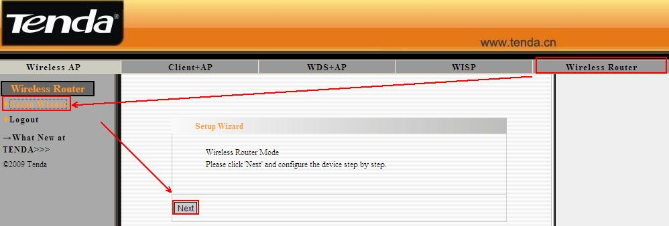
- Choose Internet Connection Type and click Next. 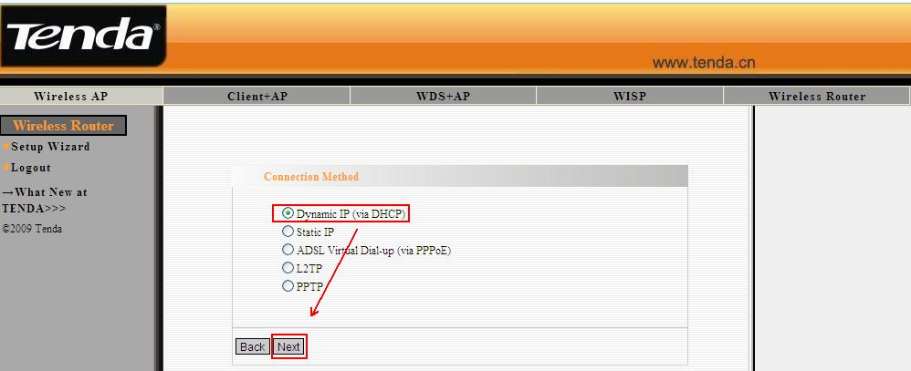
- In the Wireless Basic Setting page, you can do the basic configuration for your W150M. You can change the name of your W150M by changing the SSID and choose wireless Channel for your W150M in the page. Click Next. 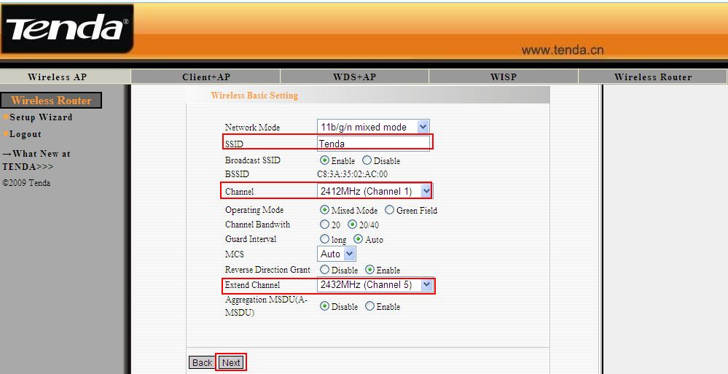
- Then in the Wireless Security Settings page, please choose WPA-Personal as Security Mode and choose AES as WPA Algorithms. And type password for wireless network in the blank of Pass Phrase. Click Next. 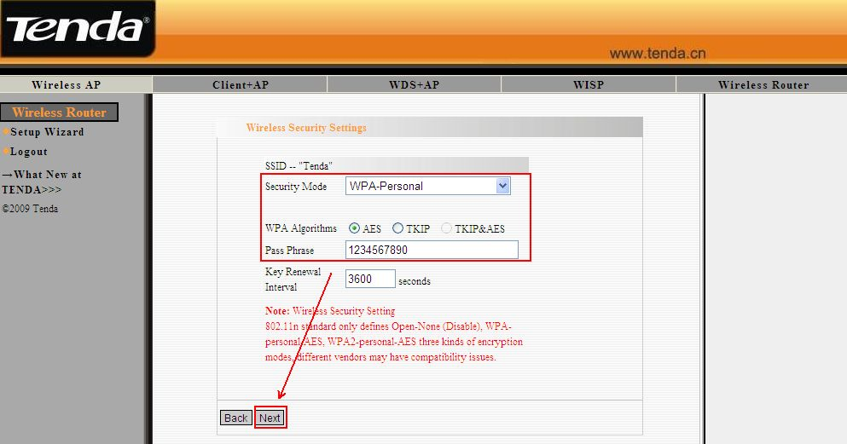
- Click Apply to save the setting.
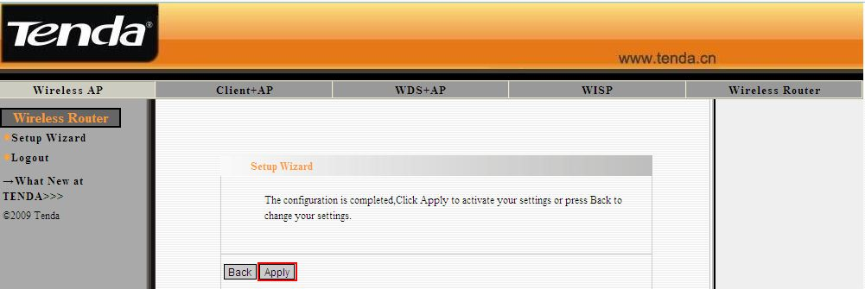
- After the configuration, connect the W150M to the modem with Ethernet cable, the wireless clients connect to the W150M can get ip automatically and connect to the Internet.

